**PRIORITIES IN THE PROJECT**

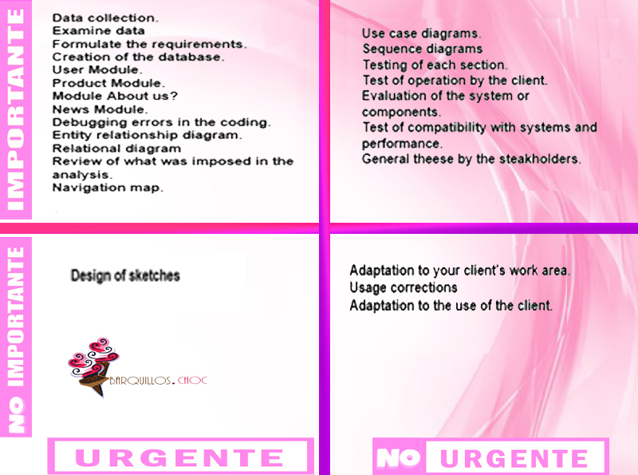

|  |  |  |
| --- | --- | --- |
| Phase | Activity | Justification |
| Analysis | Data collection | It is necessary to know the data urgently in order to know what the client needs and to be able to start with the development of the Project. |
| Examine data | Once the data has been collected, we must carefully examine each one of them in order to get the requirements translated into our project. |
| Formulate the client´s requirements | It is important to establish the services that the system has to offer and the restrictions associated with its operation as well is urgent to delimit the scope it will have. |
| Design | Use case diagrams | These diagrams are important, although many say that they are not important, since they help us to know what the system should do even though they are not very urgent because new system requirements can generate new uses-cases. |
| Sequence diagrams | These diagrams are important because they show the interaction between the different objects, they are not very urgent because new requirements of the system can generate sequence diagrams. |
| Navigation map | It is important to know how the navigation of the project will be, that is, how they communicate with each other or how they will have access to each of the sections. Also, it is important to know before you start programming. |
| Entity relationship diagram | It is important to have a representation of the relationship that will be had between the entities of the database and it is urgent to know what attributes each entity will have to be able to make the database. |
| Relational diagram | It is important to know the relationships that the different tables of the database will have and it is urgent to be able to enhance the database and start programming each section. |
| Design of sketches | It is not important, but it is urgent to know how the screens will be designed or how it is proposed that the different sections will be seen and also be able to show the client how the design could be seen. |
| Check | Review of what imposed in the analysis | It is important and urgent to know what has to be done to be able to do it in the best way and in the established time. |
| Evaluation of the system or components | It is important but not urgent because you have to know what system and components can be used, but they can change. |
| Programación | Creation of database | It is important and urgent to know what fields the database has and what types of data to work with the programming. |
| User module | It is important and urgent to make the user module because it is one of the main modules of the site since the user is the one who will administer the site. |
| Products module | It is important and urgent because it is intended to show the products offered by the company, it is also the main requirements that the client established because he wants the products to be made known. |
| Module about us? | It is important and urgent because it will show important company information. |
| News module | It is important and urgent because the news is placed on the main screen, that is to say in the index, and an advance must be delivered every certain time and it is the first thing that is shown to the client. |
| Pruebas | Testing of each section | It is important because it has to be verified that it does not contain any faults and it is not urgent why the whole project should be finished if problems arise and try to correct them within the programming. |
| Test of operation by the client | It is important that the client reviews the proper functioning of the site, but it is not urgent because it must go through other tests before delivering it to the client. |
| Adaptation to your Work area | The client can change the work area, which is why it is not important nor urgent to adapt it to a single work area. |
| Debugging of the errors in coding | It is important and urgent because if errors occur in the tests, they should be corrected as soon as possible to be able to deliver the project in a timely manner. |
| Test of compatibility with systems and performance | It is important because you must work on a specific system and must have a good performance. It is not very urgent because it must be established in what system you can work since the requirements are obtained, so it is no longer of great importance. |
| General testing by stakeholders | It is important that the stakeholders perform a test to be able to know what faults they find in the system, since they do not know specifically how the system works, but it is not very urgent. |